Project Report

1. Introduction

1.1 Overview



1.2 Purpose

Announced in January 2007, the original iphone was introduced by steve Jobs as a combination of the ipod, a revolutionary mobile phone and a breakthrough Internet communicator.

People used to talk face-to-face, write letters,send emails, make phone calls, text,tweet, post pictures, and shere videos online . All of these methods allow us to connect with others quickly and easily.

2.Problem Definition & Design Thinking

2.1 Emapathy Map

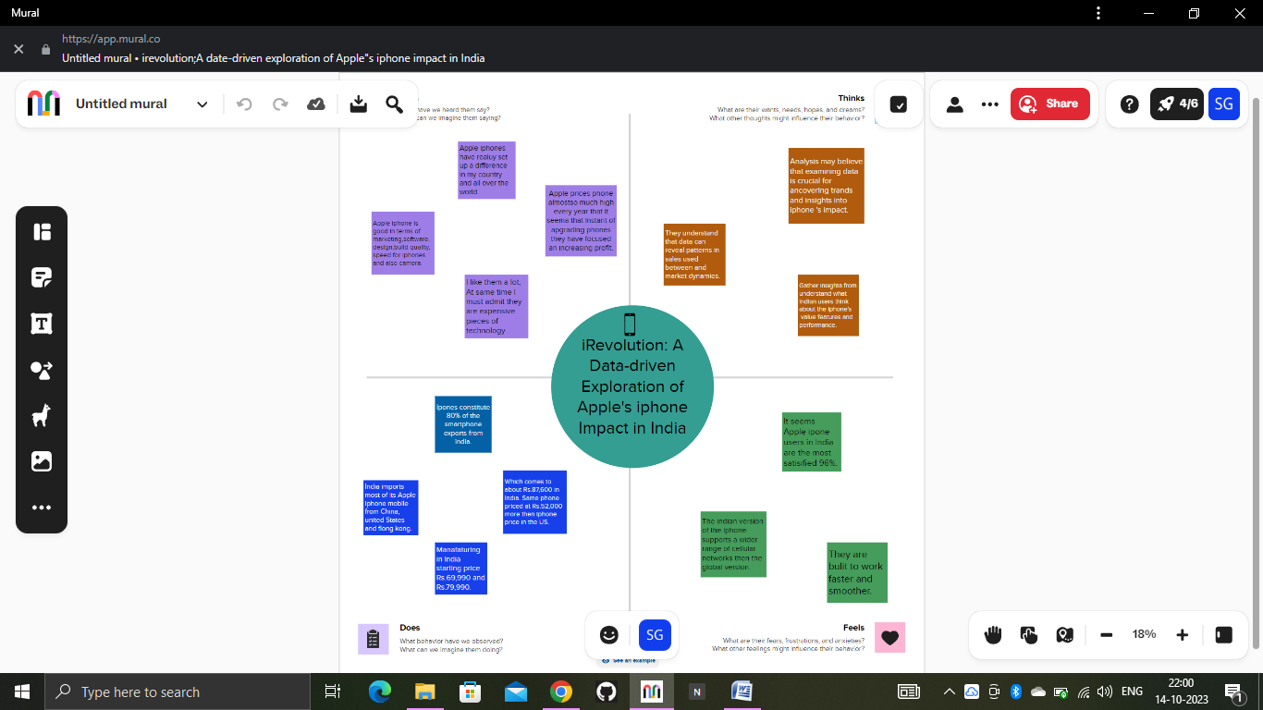

2.2 Ideation & Brainstorming Map

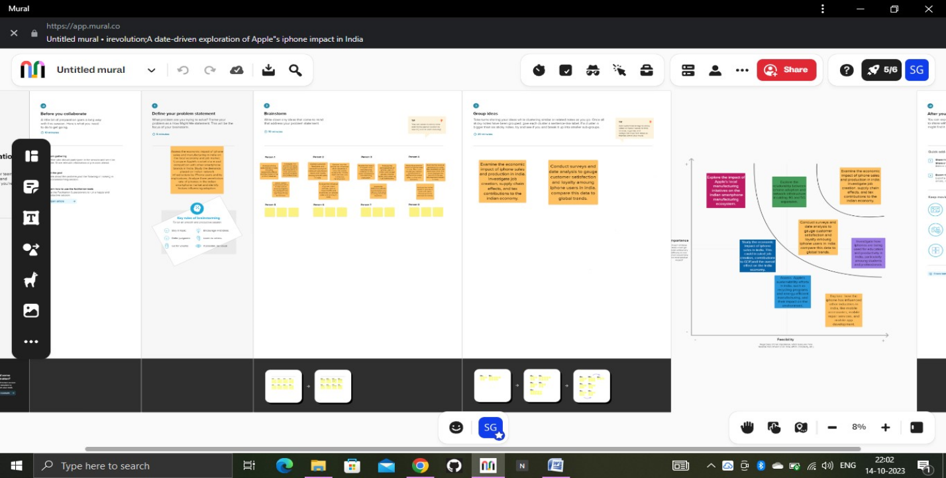3. Result

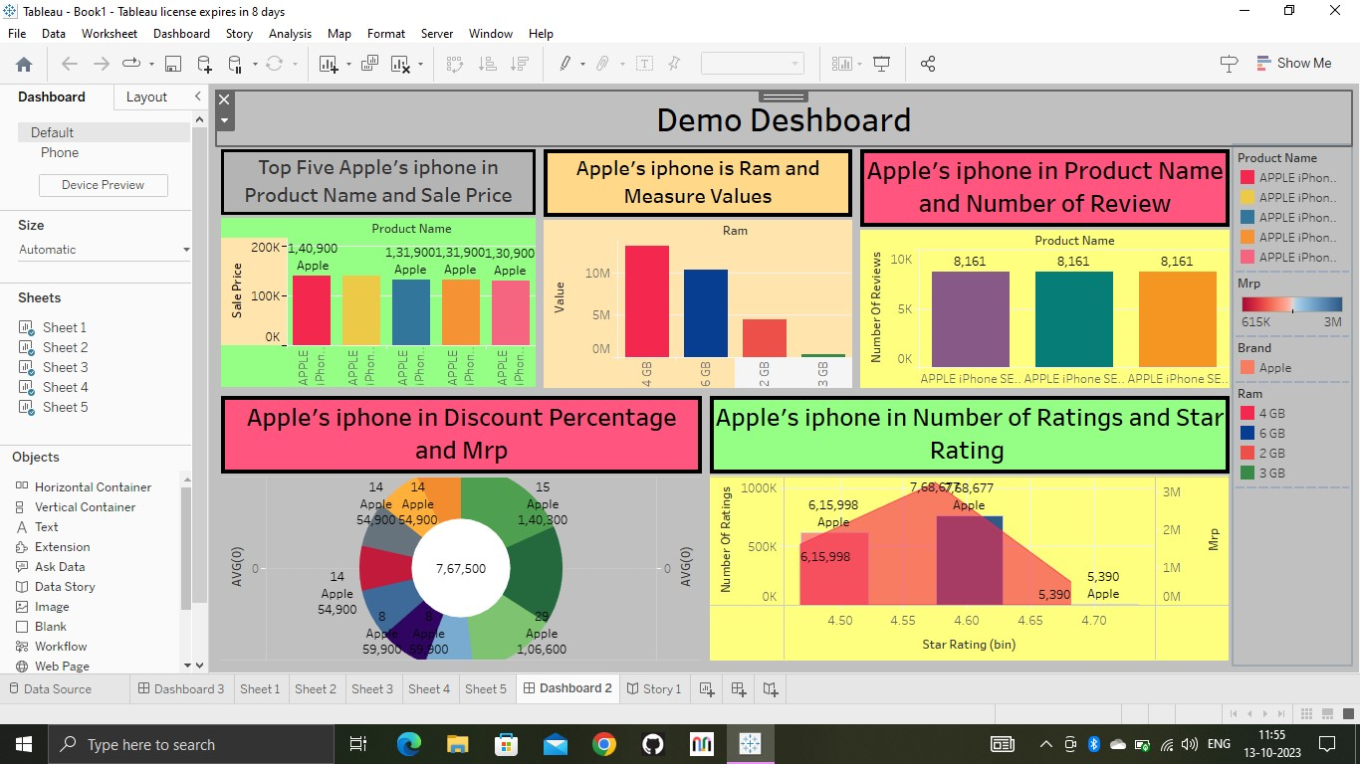4. Advantages & Disadvantages

1) User- Friendly Interface.

2) High- Quality Display.

3) Advanced Camera.

4) Apps Ecosystem.

5) Seamless integration with other Apple devices.

Disadvantages:

1) Cost.

2) Non- Removable Battery.

3) Limited customization.

4) No Expandable Storage.

5) Frailty.

5. Applications

Tablaue Desktop 2023.2

6. Conclusion

Apple iphone is a well known fortune 500 company with excellent products.The apple iphone is the valuable company in the world. For 35 years Apple has been a trand – sctter company able to forease the future.

Bacause their strength is the innovation and they know. How to think different.

7) Future Scope

Set to come out in the fall of 2024. The iphone 16 models could feature the first Apple- designed modern chip. Puls there could be updated face ID technology ,a possible portless design a high-end “Ultra” model.

Apple’s iphone an incrementally improve its hardward products and even introduce some new oncw.